The Incorrect String 1366

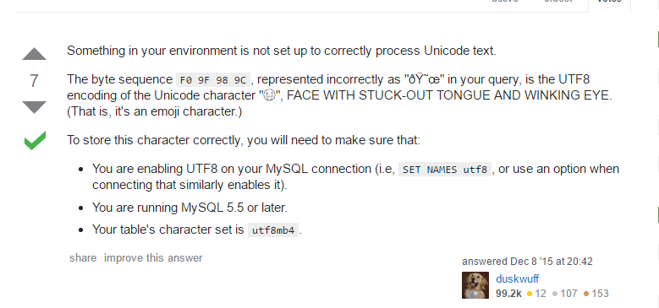

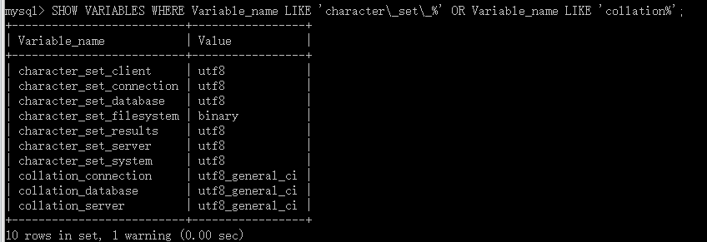



# For advice on how to change settings please see

# http://dev.mysql.com/doc/refman/5.7/en/server-configuration-defaults.html

# *** DO NOT EDIT THIS FILE. It's a template which will be copied to the

# *** default location during install, and will be replaced if you

# *** upgrade to a newer version of MySQL.

[mysqld]

# Remove leading # and set to the amount of RAM for the most important data

# cache in MySQL. Start at 70% of total RAM for dedicated server, else 10%.

# innodb_buffer_pool_size = 128M

# Remove leading # to turn on a very important data integrity option: logging

# changes to the binary log between backups.

# log_bin

# These are commonly set, remove the # and set as required.

# basedir = .....

# datadir = .....

# port = .....

# server_id = .....

init_connect='SET collation_connection = utf8_unicode_ci'

character-set-server = utf8

collation-server = utf8_unicode_ci

[client]

default-character-set = utf8

# Remove leading # to set options mainly useful for reporting servers.

# The server defaults are faster for transactions and fast SELECTs.

# Adjust sizes as needed, experiment to find the optimal values.

# join_buffer_size = 128M

# sort_buffer_size = 2M

# read_rnd_buffer_size = 2M

sql_mode=NO_ENGINE_SUBSTITUTION,STRICT_TRANS_TABLES